IMPORTANT CODING QUESTIONS IN C

- PROGRAM FOR EVEN AND ODD:

#include <stdio.h>
void main()
{
int n;
printf("enter the number\n");
scanf("%d",&n);
if(n%2==0)
{
printf("even number\n");
}
else
{
printf("odd number\n");
}
return 0;
}

- Program to break the numbers then print their sum :

#include <stdio.h>
void main()
{
int a,b,s=0;
printf("enter a number\n);
scanf("%d",&a);
while(a>0)
{
b=a%10;
s=s+b;
a=a/10;

}
printf("sum =%d",s);
return 0;
}

- Palindrome number:
#include <stdio.h>
void main()
{
int a,b,s=0,on;
printf("enter a number\n");
scanf("%d",&a);
on = a;
while(a>0)
{
b=a%10;
s=s*10+b;
a=a/10;
}
printf("s =%d\n",s);

if(s==on)
{
printf("Palindrome number\n");

}
else
{
printf("Not Palindrome\n");

}
return 0;
}

- Palindrome string :
#include <stdio.h>
#include <string.h>
int main()
{
char a[10], b[10];

printf("Enter a word to check whether it's a palindrome\n");
gets(a);

strcpy(b, a);
strrev(b);

if (strcmp(a, b) == 0)
printf("The string is a palindrome.\n");
else
printf("The string isn't a palindrome.\n");

return 0;
}

OR

#include <stdio.h>
#include <string.h>

int main()
{
char text[100];
int begin, middle, end, length = 0;

gets(text);

while ( text[length] != '\0' )
length++;

end = length - 1;
middle = length/2;

for( begin = 0 ; begin < middle ; begin++ )
- {
if ( text[begin] != text[end] )
{
printf("Not a palindrome.\n");
break;
}
end--;
}
if( begin == middle )
printf("Palindrome.\n");

return 0;
}

- Multiplication Table:
#include <stdio.h>
int main()
{
int a,b,c;
printf("enter a number:");
scanf("%d",&a);
printf("Table of %d=\n",a);
for(b=1;b<=10;b++)
{
c=a*b;
printf("\n%d*%d=%d",a,b,c);

}
return 0;
}

- Sum of first n Natural Numbers

#include <stdio.h>
void main()
{
int n,i,sum=0;
printf("enter number\n");
scanf("%d",&n);
for(i=1;i<=n;i++)
{
sum=sum+i;
}
printf("sum of the numbers is %d:",sum);
return 0;

}
- Factorial of a number:

#include <stdio.h>
void main()
{
int n,i,fact=1;
printf("enter a number\n");
scanf("%d",&n);
for(i=1;i<=n;i++)
{
fact*=i;
}
printf("factorial is :%d \n",fact);
return 0;

}

- Factors of a number :
#include <stdio.h>
void main()
{
int n,i;
printf("enter a number:\n");
scanf("%d",&n);
for(i=1;i<=n;i++)
{
if(n%i==0)
{
printf("%d\n",i);

}
}

return 0;

}

- Perfect number:

#include <stdio.h>
void main()
{
int n,i,sum=0;
printf("enter a number:\n");
scanf("%d",&n);
for(i=1;i<=n;i++)
{
if(n%i==0)
{
sum=sum+i;

}
}
if(2*n==sum)
{
printf("Perfect number");

}
else
{
printf("not a perfect number");
}
return 0;
}

- Prime number:

#include <stdio.h>
void main()
{
int n,i,count=0;
printf("enter a number:\n");
scanf("%d",&n);
for(i=1;i<=n;i++)
{
if(n%i==0)
{
count ++;

}
}
if(count ==2)
{
printf("Prime number");

}
else
{
printf("not a prime number");
}
return 0;
}

- Display Digits of a number :

#include <stdio.h>
void main()
{
int a,c=0;
printf("enter a number\n");
scanf("%d",&a);
while(a!=0)
{
a=a/10;
c++;
}
printf("%d\n",c);

return 0;
}

- Armstrong number :
#include <stdio.h>
int main() {
int num, originalNum, remainder, result = 0;
printf("Enter a three-digit integer: ");
scanf("%d", &num);
originalNum = num;

while (originalNum != 0) {
// remainder contains the last digit
remainder = originalNum % 10;

result += remainder * remainder * remainder;

// removing last digit from the orignal number
originalNum /= 10;
}

if (result == num)
printf("%d is an Armstrong number.", num);
else
printf("%d is not an Armstrong number.", num);

return 0;
}

- GDC of a number :

#include <stdio.h>
void main()
{
int m,n;
printf("enter 2 number \n");
scanf("%d %d",&m,&n);
while(m!=n)
{
if(m>n)
{
m=m-n;

}
else if(n>m)
{
n=n-m;
}
printf("%d\n",m);
}
return 0;
}

- Fibonacci series : 0 1 1 2 3 5 8 13 21 34 55-------

#include <stdio.h>
void main()
{
int a=0,b=1,c,d=1,e;
printf("enter a number\n");
scanf("%d",&c);
printf("%d\t%d",a,b);
while(d<=c-2)
{
e=a+b;
printf("\t%d",e);
d++;
a=b;
b=e;
}
return 0;

}

- Neon Number : 9 =9^2=81=8+1=9

#include <stdio.h>
void main()
{
int a,b,s=0,d,e;
printf("enter a number\n");
scanf("%d",&a);
e=a;
b=a*a;
while(b!=0)
{
d=b%10;
s=s+d;
b=b/10;
}
if(s==e)
{
printf("Neon NUmber\n");
}
else
{
printf("Not a Neon Number\n");
}
return 0;

}
- Leap Year Programme : 2000=leap year ,2005= not a leap year

#include <stdio.h>

int main() {
int year;
printf("enter a year\n");
scanf("%d",&year);

if (((year % 4 == 0) && (year % 100!= 0)) || (year%400 == 0))
printf("%d is a leap year", year);
else
printf("%d is not a leap year", year);

return 0;
}

- 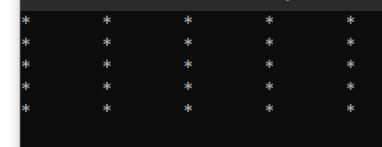

#include <stdio.h>

int main() {
int i,j;
for(i=1;i<=5;i++)
{
for(j=1;j<=5;j++)
{
printf("*\t");
}
printf("\n");
}
return 0;
}

- 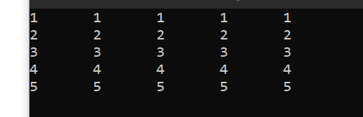

#include <stdio.h>

int main() {
int i,j;
for(i=1;i<=5;i++)
{
for(j=1;j<=5;j++)
{
printf("%d\t",i);
}
printf("\n");
}
return 0;
}

- 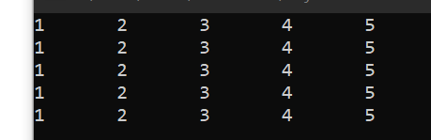

#include <stdio.h>

int main() {
int i,j;
for(i=1;i<=5;i++)
{
for(j=1;j<=5;j++)
{
printf("%d\t",j);
}
printf("\n");
}
return 0;
}

- 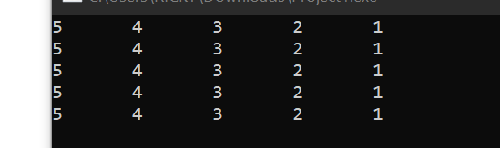

#include <stdio.h>

int main() {
int i,j;
for(i=5;i>=1;i--)
{
for(j=5;j>=1;j--)
{
printf("%d\t",j);
}
printf("\n");
}
return 0;
}
- 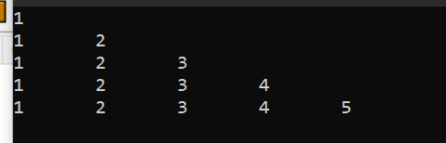

#include <stdio.h>

int main() {
int i,j;
for(i=1;i<=5;i++)
{
for(j=1;j<=i;j++)
{
printf("%d\t",j);
}
printf("\n");
}
return 0;
}

- 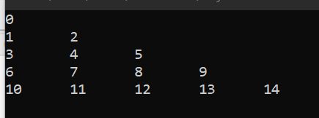

#include <stdio.h>

int main() {
int i,j,k;
for(i=1;i<=5;i++)
{
for(j=1;j<=i;j++)
{
printf("%d\t",k);
k++;
}
printf("\n");
}
return 0;
}

- 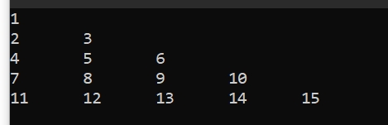

#include <stdio.h>

int main() {
int i,j,k=1;
for(i=1;i<=5;i++)
{
for(j=1;j<=i;j++)
{
printf("%d\t",k);
k++;
}
printf("\n");
}
return 0;
}

- 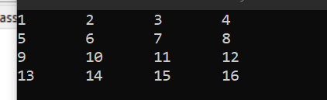

#include <stdio.h>

int main() {
int i,j,count=1;
for(i=1;i<=4;i++)
{
for(j=1;j<=4;j++)
{
printf("%d\t",count);
count ++;
}
printf("\n");
}
return 0;
}

- 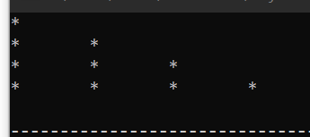

#include <stdio.h>

int main() {
int i,j,count=1;
for(i=1;i<=4;i++)
{
for(j=1;j<=4;j++)
{
if(i>=j)
{

printf("*\t");
}
}
printf("\n");
}
return 0;
}

- 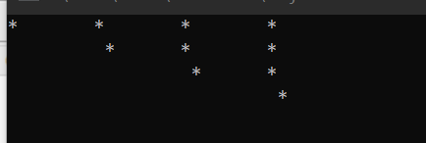

#include <stdio.h>

int main() {
int i,j,count=1;
for(i=1;i<=4;i++)
{
for(j=1;j<=4;j++)
{
if(i>j)
{

printf("\t ");

}
else
{
printf("*\t");
}
}
printf("\n");
}
return 0;
}

- 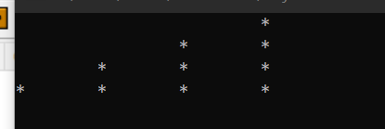

#include <stdio.h>

int main() {
int i,j,count=1;
for(i=1;i<=4;i++)
{
for(j=1;j<=4;j++)
{
if(i+j>4)
{

printf("*\t");

}
else
{
printf("\t");
}
}
printf("\n");
}
return 0;
}

- 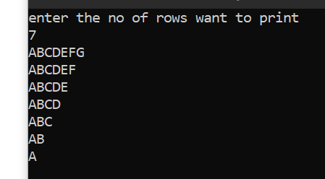

#include <stdio.h>

int main() {
int i,j,rows;
printf("enter the no of rows want to print\n");
scanf("%d",&rows);
for(i=rows;i>=1;i--)
{
for(j=1;j<=i;j++)
{
printf("%c",j+64);
}
printf("\n");
}
return 0;
}

- Transpose of a matrix :

#include <stdio.h>
int main() {
int a[10][10], transpose[10][10], r, c;
printf("Enter rows and columns: ");
scanf("%d %d", &r, &c);

// asssigning elements to the matrix
printf("\nEnter matrix elements:\n");
for (int i = 0; i < r; ++i)
for (int j = 0; j < c; ++j) {
printf("Enter element a%d%d: ", i + 1, j + 1);
scanf("%d", &a[i][j]);
}

// printing the matrix a[][]
printf("\nEntered matrix: \n");
for (int i = 0; i < r; ++i)
for (int j = 0; j < c; ++j) {
printf("%d ", a[i][j]);
if (j == c - 1)
printf("\n");
}

// computing the transpose
for (int i = 0; i < r; ++i)
for (int j = 0; j < c; ++j) {
transpose[j][i] = a[i][j];
}

// printing the transpose
printf("\nTranspose of the matrix:\n");
for (int i = 0; i < c; ++i)
for (int j = 0; j < r; ++j) {
printf("%d ", transpose[i][j]);
if (j == r - 1)
printf("\n");
}
return 0;
}

- Addition Of Two Matrix :
#include <stdio.h>
int main() {
int r, c, a[100][100], b[100][100], sum[100][100], i, j;
printf("Enter the number of rows (between 1 and 100): ");
scanf("%d", &r);
printf("Enter the number of columns (between 1 and 100): ");
scanf("%d", &c);

printf("\nEnter elements of 1st matrix:\n");
for (i = 0; i < r; ++i)
for (j = 0; j < c; ++j) {
printf("Enter element a%d%d: ", i + 1, j + 1);
scanf("%d", &a[i][j]);
}

printf("Enter elements of 2nd matrix:\n");
for (i = 0; i < r; ++i)
for (j = 0; j < c; ++j) {
printf("Enter element b%d%d: ", i + 1, j + 1);
scanf("%d", &b[i][j]);
}

// adding two matrices
for (i = 0; i < r; ++i)
for (j = 0; j < c; ++j) {
sum[i][j] = a[i][j] + b[i][j];
}

// printing the result
printf("\nSum of two matrices: \n");
for (i = 0; i < r; ++i)
for (j = 0; j < c; ++j) {
printf("%d ", sum[i][j]);
if (j == c - 1) {
printf("\n\n");
}
}

return 0;
}

- Multiplication Of Two Matrix :
#include <stdio.h>

// function to get matrix elements entered by the user
void getMatrixElements(int matrix[][10], int row, int column) {

printf("\nEnter elements: \n");

for (int i = 0; i < row; ++i) {
for (int j = 0; j < column; ++j) {
printf("Enter a%d%d: ", i + 1, j + 1);
scanf("%d", &matrix[i][j]);
}
}
}

// function to multiply two matrices
void multiplyMatrices(int first[][10],
int second[][10],
int result[][10],
int r1, int c1, int r2, int c2) {

// Initializing elements of matrix mult to 0.
for (int i = 0; i < r1; ++i) {
for (int j = 0; j < c2; ++j) {
result[i][j] = 0;
}
}

// Multiplying first and second matrices and storing it in result
for (int i = 0; i < r1; ++i) {
for (int j = 0; j < c2; ++j) {
for (int k = 0; k < c1; ++k) {
result[i][j] += first[i][k] * second[k][j];
}
}
}
}

// function to display the matrix
void display(int result[][10], int row, int column) {

printf("\nOutput Matrix:\n");
for (int i = 0; i < row; ++i) {
for (int j = 0; j < column; ++j) {
printf("%d ", result[i][j]);
if (j == column - 1)
printf("\n");
}
}
}

int main() {
int first[10][10], second[10][10], result[10][10], r1, c1, r2, c2;
printf("Enter rows and column for the first matrix: ");
scanf("%d %d", &r1, &c1);
printf("Enter rows and column for the second matrix: ");
scanf("%d %d", &r2, &c2);

// Taking input until
// 1st matrix columns is not equal to 2nd matrix row
while (c1 != r2) {
printf("Error! Enter rows and columns again.\n");
printf("Enter rows and columns for the first matrix: ");
scanf("%d%d", &r1, &c1);
printf("Enter rows and columns for the second matrix: ");
scanf("%d%d", &r2, &c2);
}

// get elements of the first matrix
getMatrixElements(first, r1, c1);

// get elements of the second matrix
getMatrixElements(second, r2, c2);

// multiply two matrices.
multiplyMatrices(first, second, result, r1, c1, r2, c2);

// display the result
display(result, r1, c2);

return 0;
}

- Perfect no. between a range

#include<stdio.h>
#include<conio.h>
void main()
{
int num, Sum = 0, i, Max, Min;
// Take two number from the user: min and max
printf("Enter the minimum and the maximum value\n");
scanf("%d %d", &Min, &Max);

printf("\n Perfect Number between %d and %d are\n ", Min, Max);
for(num = Min; num <= Max; num++)
{
for(i = 1, Sum = 0; i < num; i++)
{
if(num %i == 0)
Sum = Sum + i;
}
if(Sum == num)
printf("%d \t", num);
}
getch();
}

- Sum of two starting no. with skipping of two no. and then sum of next number

#include<stdio.h>
#include<conio.h>
Void main()
{
Int a[100],I,n,sum=0;
Clrscr();

Printf(“enter required number\n”);
Scanf(“%d”,&n);
Printf(“enter the starting values \n”);
For(i=0;i<n;i++)
{
Scanf(“%d”,&a[i]);
}
Printf(“\n”);
For(i=0;i<n;i++)
{
Printf(“%d”,a[i]);
}
Printf(“\n”);
For(i=0;i<n;i+=4)
{
If(n%2==0)
{
If(i!=n-1)
{
Sum=sum+a[i]+a[i+1];
}
Else
{
If(i!=n-1)
{
Sum=sum+a[i]+a[i+1];
}
Else if(i==n-1)
{
Sum=sum+a[i];
}
}
}
Printf(“the sum is %d”,sum);
Getch();
}

#include <stdio.h>
#include <string.h>

union Data {
int i;
float f;
char str[20];
};

int main( ) {

union Data data;

data.i = 10;
data.f = 220.5;
strcpy( data.str, "C Programming");

printf( "data.i : %d\n", data.i);
printf( "data.f : %f\n", data.f);
printf( "data.str : %s\n", data.str);

return 0;
}

Here, the size of sJob is 40 bytes because
- the size of name[32] is 32 bytes
- the size of salary is 4 bytes
- the size of workerNo is 4 bytes
However, the size of uJob is 32 bytes. It's because the size of a union variable will always be the size of its largest element. In the above example, the size of its largest element, (name[32]), is 32 bytes.
With a union, all members share the same memory.

OTHER IMPORTANT QUESTIONS :

- Income Tax code :

#include<stdio.h>

int main(){
float tax = 0, income;
printf("Enter your income\n");
scanf("%f", &income);

if(income>=250000 && income<=500000){
tax = tax + 0.05 * (income - 250000);
}

if (income >= 500000 && income <= 1000000)
{
tax = tax + 0.20 * (income - 500000);
}

if (income >= 1000000)
{
tax = tax + 0.30 * (income - 1000000);
}

printf("Your net income tax to be paid by 26th of this month is %f\n", tax);

return 0;
}

- Lower case or not :
#include<stdio.h>

int main(){
// 97-122 = a-z ASCII Values
char ch;
printf("Enter the character\n");
scanf("%c", &ch);
if(ch<=122 && ch>=97){
printf("It is lowercase");
}
else{
printf("It is not lowercase");
}
return 0;
}

- Switch case :
#include<stdio.h>

int main(){
int rating;
printf("Enter your rating (1-5)\n");
scanf("%d", &rating);
switch(rating){
case 1:
printf("Your rating is 1\n");
break;
case 2:
printf("Your rating is 2\n");
break;
case 3:
printf("Your rating is 3\n");
break;
case 4:
printf("Your rating is 4\n");
break;
case 5:
printf("Your rating is 5\n");
break;
default :
printf("Invalid rating!\n");
break;
}

return 0;
}

- Ternary operator
#include<stdio.h>

int main(){
int a;
printf("Enter a\n");
scanf("%d", &a);
// One liner
(a < 5) ? printf("A is less than 5") : printf("A is not less than 5");
return 0;
}

- Increment operator :
#include<stdio.h>

int main(){
int i = 5;
printf("The value after i++ is %d\n", ++i);
i++; // ---> Pehle print fir increment
++i; // ---> Pehle increment fir print kare
printf("The value of i is %d\n", i);

i+=10; //--> Increments i by 10
printf("The value of i is %d\n", i);
return 0;
}

- Addition of 2 numbers using 2 functions :
#include<stdio.h>
// sum is a function which takes a and b as input and returns an integer as an output
int sum(int a, int b); // function prototype declaration

int main(){
int c;
c = sum(2, 15); // function call
printf("The value of c is %d\n", c);
return 0;
}

int sum (int a, int b){
int c;
c = a + b;
return c;
}

- Factorial using recursion :

#include<stdio.h>
int factorial(int x);

int main(){
int a = 5;
printf("The value of factorial %d is %d", a, factorial(a));
return 0;
}

int factorial(int x){
printf("Calling factorial(%d)\n", x);
if (x==1 || x==0){
return 1;
}
else{
return x * factorial(x-1);
}
}

- *
***
*****

#include<stdio.h>
void printPattern(int n);
int main(){
int n =4;
printPattern(n);
return 0;
}
// for n = 3
// *
// ***
// *****
// 1 - 1
// 2 - 3
// 3 - 5
// (2n-1)
void printPattern(int n){
if (n==1){
printf("*\n");
return;
}
printPattern(n-1);
for(int i=0;i<(2*n-1);i++){
printf("*");
}
printf("\n");
}

- Pointer basics :
#include<stdio.h>

int main(){
int i = 34;
int *j = &i; // j will now store the address of i
printf("The value of i is %d\n", i);
printf("The value of i is %d\n", *j);
printf("The address of i is %u\n", &i);
printf("The address of i is %u\n", j);
printf("The address of j is %u\n", &j);
printf("The value of j is %u\n", *(&j));
return 0;
}

- Call by value :
#include<stdio.h>
int sum (int a, int b);
int main(){
int x=4, y=7;
printf("The value of x and y is %d and %d\n", x, y);
printf("The value of 4+7 is %d\n", sum(x, y));
printf("The value of x and y after function call is %d and %d\n", x, y);
return 0;
}
int sum (int a, int b){
int c;
c = a + b;
b =3434;
a = 23432;
return c;
}

- Call by reference :
#include<stdio.h>
void wrong_swap(int a, int b);
void swap(int *a, int *b);

int main(){
int x=3, y=4;
printf("The value of x and y before swap is %d and %d\n", x, y);
//wrong_swap(x, y); // will not work due to call by value
swap(&x, &y); // will work due to call by reference
printf("The value of x and y after swap is %d and %d\n", x, y);

return 0;
}

void wrong_swap(int a, int b){
int temp;
temp = a;
a = b;
b = temp;
}

void swap(int *a, int *b){
int temp;
temp = *a;
*a = *b;
*b = temp;
}
- Comparison between strings and char using strcmp:
#include<stdio.h>
#include<string.h>

int main(){
char st1[34];
char st2[34];
char c;
int i =0;

printf("Enter the value of first string\n");
scanf("%s", st1);
printf("Enter the value of second string character by character\n");

while(c!='\n'){
fflush(stdin);
scanf("%c", &c);
st2[i] = c;
i++;
}
st2[i-1]= '\0';

printf("The value of st1 is %s\n", st1);
printf("The value of st2 is %s\n", st2);
printf("strcmp for these strings returns %d", strcmp(st1, st2));

return 0;
}

- Calcualte length of a string without using library functions :
#include<stdio.h>
int strlen(char * st){
char *ptr = st;
int len=0;
while(*ptr!='\0'){
len++;
ptr++;
}
return len;
}

int main(){
char st[] = "Harry";
int l = strlen(st);
printf("The length of this string is %d", l);
return 0;
}

- Slicing of a string :
#include<stdio.h>
void slice(char *st, int m, int n){
int i = 0;
while((m+i)<n){
st[i] = st[i+m];
i++;
}
st[i] = '\0';
}

int main(){
char st[] = "Harrysfsdfsdf";
slice(st, 1, 6);
printf("%s", st);
return 0;
}

- Encrypted string :
#include<stdio.h>
void encrypt(char *c){
char *ptr = c;
while(*ptr!='\0'){
*ptr = *ptr + 1;
ptr++;
}
}

int main(){
char c[] = "come to this room";
encrypt(c);
printf("Encrypted string is: %s", c);
return 0;
}

- Decrypt :
#include<stdio.h>
void decrypt(char *c){
char *ptr = c;
while(*ptr!='\0'){
*ptr = *ptr - 1;
ptr++;
}
}

int main(){
char c[] = "dpnf!up!uijt!sppn";
decrypt(c);
printf("Decrypted string is: %s", c);
return 0;
}

- Counting no of occurrences :
#include<stdio.h>
int occurence(char st[], char c){
char *ptr = st;
int count=0;
while(*ptr!='\0'){
if (*ptr==c){
count++;
}
ptr++;
}
return count;
}
int main(){
char st[] = "Harry7777";
int count = occurence(st, '7');
printf("Occurences = %d", count);
return 0;
}

- Basic structure code :
#include<stdio.h>
#include<string.h>

struct employee{
int code;
float salary;
char name[10];
};

int main(){
int a =34;
char b = 'g';
float d = 234.3543;
// employee e1;
// e1.salary = 34.454; --->wont work without employee structure

struct employee e1;
e1.code = 100;
e1.salary = 34.454;
// e1.name = "Harry"; --> wont work
strcpy(e1.name, "Harry");

printf("%d\n", e1.code);
printf("%.3f\n", e1.salary);
printf("%s\n", e1.name);

return 0;
}

- Arrays of structures :
#include<stdio.h>
#include<string.h>

struct employee{
int code;
float salary;
char name[20];
};

int main(){
struct employee facebook[100];

facebook[0].code = 100;
facebook[0].salary = 100.45;
strcpy(facebook[0].name, "Harry");

facebook[1].code = 101;
facebook[1].salary = 90.45;
strcpy(facebook[1].name, "Rohan");

facebook[2].code = 102;
facebook[2].salary = 110.45;
strcpy(facebook[2].name, "SkillKhiladi");
printf("Done");

return 0;
}

- Pointer to structures :
#include<stdio.h>
#include<string.h>

struct employee{
int code;
float salary;
char name[20];
};

int main(){
struct employee e1;
struct employee *ptr;

ptr = &e1;
//(*ptr).code = 101; //or you can also write: ptr->code = 101;
ptr->code = 101;
printf("%d", e1.code);

return 0;
}

- Good question on structure :
#include<stdio.h>

struct vector{
int x;
int y;
};

struct vector sumVector(struct vector v1, struct vector v2){
struct vector result;
result.x = v1.x + v2.x;
result.y = v1.y + v2.y;
return result;
}
int main(){
struct vector v1, v2, sum;
v1.x = 4;
v1.y = 9;
printf("X dim is %d and Y dim is %d\n", v1.x, v1.y);

v2.x = 5;
v2.y = 4;
printf("X dim is %d and Y dim is %d\n", v2.x, v2.y);

sum = sumVector(v1, v2);
printf("X dim of result is %d and Y dim is %d\n", sum.x, sum.y);
return 0;
}

- Another Good question on structures:
#include<stdio.h>

typedef struct complex{
int real;
int complex;
}comp;

void display(comp c){
printf("The value of real part is %d\n", c.real);
printf("The value of Imaginary part is %d\n", c.complex);
}

int main(){
comp cnums[5];
for(int i=0; i<5; i++){
printf("Enter the real value for %d num\n", i+1);
scanf("%d", &cnums[i].real);

printf("Enter the complex value for %d num\n", i+1);
scanf("%d", &cnums[i].complex);
}
for(int i=0; i<5; i++){
display(cnums[i]);
}
return 0;
}

- Comparison date of birth using structures :
#include<stdio.h>

typedef struct date{
int date;
int month;
int year;
}date;

void display(date d){
printf("The date is: %d/%d/%d\n", d.date, d.month, d.year);
}

int dateCmp(date d1, date d2){
// Make decision on the basis of Year comparison
if(d1.year>d2.year){
return 1;
}
if(d1.year<d2.year){
return -1;
}

// Make decision on the basis of Month comparison
if(d1.month>d2.month){
return 1;
}
if(d1.month<d2.month) {
return -1;
}

// Make decision on the basis of Date comparison
if(d1.date>d2.date){
return 1;
}
if(d1.date<d2.date) {
return -1;
}
return 0;
}
int main(){
date d1 = {5, 11, 31};
date d2 = {5, 11, 31};
display(d1);
display(d2);
int a = dateCmp(d1, d2);
printf("Date Comparison function returns: %d", a);

return 0;
}

- File reading :
#include<stdio.h>

int main(){
FILE *ptr;
int num;
int num2;
ptr = fopen("Harry.txt", "r");
fscanf(ptr, "%d", &num);
fscanf(ptr, "%d", &num2);
fclose(ptr);
printf("The value of num is %d\n", num);
printf("The value of num2 is %d\n", num2);
return 0;
}

- Checking file is empty or not :
#include<stdio.h>

int main(){
FILE *ptr;
int num;
int num2;
ptr = fopen("Harr3y.txt", "r");
if (ptr == NULL){
printf("This file does not exist\n");
}
else{
fscanf(ptr, "%d", &num);
fscanf(ptr, "%d", &num2);
fclose(ptr);
printf("The value of num is %d\n", num);
printf("The value of num2 is %d\n", num2);
}
return 0;
}

- Writing into file :
#include<stdio.h>

int main(){
FILE *fptr;
int number = 45;
fptr = fopen("generated.txt", "w");
fprintf(fptr, "The number is %d\n", number);
fprintf(fptr, "Thanks for using fprintf", number);
fclose(fptr);

return 0;
}

- Malloc :
#include<stdio.h>
#include<stdlib.h>

int main(){
int *ptr;
// Sizeof operator in C
// printf("The size of int on my pc is %d\n", sizeof(int));
// printf("The size of float on my pc is %d\n", sizeof(float));
// printf("The size of char on my pc is %d\n", sizeof(char));
ptr = (int *) malloc(6 * sizeof(int));
for(int i=0; i<6;i++){
printf("Enter the value of %d element: \n", i);
scanf("%d", &ptr[i]);
}

for(int i=0; i<6;i++){
printf("The value of %d element is: %d\n", i, ptr[i]);
}
return 0;
}

- Calloc:
#include<stdio.h>
#include<stdlib.h>

int main(){
int *ptr;
ptr = (int *) calloc(6, sizeof(int));
// for(int i=0; i<6;i++){
// printf("Enter the value of %d element: \n", i);
// scanf("%d", &ptr[i]);
// }

for(int i=0; i<6;i++){
printf("The value of %d element is: %d\n", i, ptr[i]);
}
return 0;
}
- Free :
#include<stdio.h>
#include<stdlib.h>

int main(){
int *ptr;
int *ptr2;
// Sizeof operator in C
// printf("The size of int on my pc is %d\n", sizeof(int));
// printf("The size of float on my pc is %d\n", sizeof(float));
// printf("The size of char on my pc is %d\n", sizeof(char));
ptr = (int *) malloc(600 * sizeof(int));
for(int i=0; i<600;i++){
ptr2 = (int *) malloc(600000 * sizeof(int));
printf("Enter the value of %d element: \n", i);
scanf("%d", &ptr[i]);
free(ptr2);
}

for(int i=0; i<6;i++){
printf("The value of %d element is: %d\n", i, ptr[i]);
}
return 0;
}

- Realloc:
#include<stdio.h>
#include<stdlib.h>

int main(){
int *ptr;
ptr = (int *) malloc(6 * sizeof(int));
for(int i=0; i<6;i++){
printf("Enter the value of %d element: \n", i);
scanf("%d", &ptr[i]);
}

for(int i=0; i<6;i++){
printf("The value of %d element is: %d\n", i, ptr[i]);
}

// Reallocate ptr using realloc()
ptr = realloc(ptr, 10*sizeof(int));

for(int i=0; i<10;i++){
printf("Enter the value of %d element: \n", i);
scanf("%d", &ptr[i]);
}

for(int i=0; i<10;i++){
printf("The value of %d element is: %d\n", i, ptr[i]);
}

return 0;
}
- Difference between structure and union :

Need for Union in C programming :
C unions are used to save memory. To better understand an union, think of it as a chunk of memory that is used to store variables of different types. When we want to assign a new value to a field, then the existing data is replaced with new data. C unions allow data members which are mutually exclusive to share the same memory. This is quite important when memory is valuable, such as in embedded systems. Unions are mostly used in embedded programming where direct access to the memory is needed.

The main difference between structure and a union : is that Structs allocate enough space to store all of the fields in the struct. The first one is stored at the beginning of the struct, the second is stored after that, and so on. Unions only allocate enough space to store the largest field listed, and all fields are stored at the same space .

Syntax for Declaring a C union Syntax for declaring a union is same as that of declaring a structure except the keyword struct. Note : Size of the union is the the size of its largest field because sufficient number of bytes must be reserved to store the largest sized field. To access the fields of a union, use dot(.) operator i.e., the variable name followed by dot operator followed by field name. Initializing unions: The difference between structure and union when their initialization is given below.

union union_name {
datatype field_name;
datatype field_name;
// more variables
};

Code :
#include <stdio.h>
struct test1 {
int x, y;
};
union test {
int x, y;
};
int main() {
struct test1 t1={1,2};
union test t;
t.x = 3; // t.y also gets value 3
printf ("after fixing x value the coordinates of t will be %d %d\n\n",t.x, t.y);
t.y = 4; // t.x is also updated to 4
printf ("After fixing y value the coordinates of t will be %d %d\n\n", t.x, t.y);
printf("The coordinates of t1 are %d %d",t1.x,t1.y);
return 0;
}

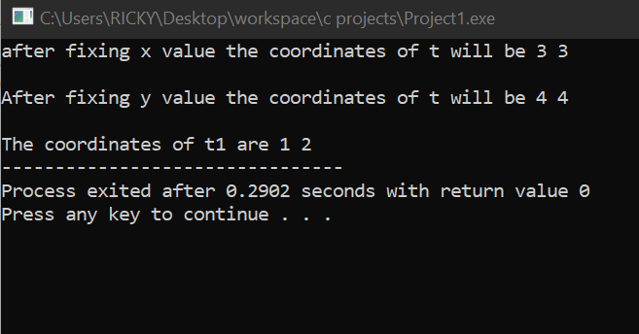

The fields of a union cannot be initialized all at once. For a structure variable the output is fine but for the union variable the answer does not seem to be correct because union can hold single value for a member at a time i.e., the data is over-written in the memory. Obviously the use case we have chosen is not suited for union but only struct. This example is only to demonstrate the behavior of union and structure.

Unions inside structure In the below code, we have union embedded with in a structure. We know, the fields of a union will share memory, so in main program we ask the user which data he/she would like to store and depending on the user choice the appropriate field will be used. By this way we can use the memory efficiently.

#include<stdio.h>
struct student {
union { //anonymous union (unnamed union)
char name[10];
int roll;
};
int mark;
};
int main() {
struct student stud;
char choice;
printf("\n You can enter your name or roll number ");
printf("\n Do you want to enter the name (y or n): ");
scanf("%c",&choice);
if(choice=='y'||choice=='Y') {
printf("\n Enter name: ");
scanf("%s",stud.name);
printf("\n Name:%s",stud.name);
}
else {
printf("\n Enter roll number");
scanf("%d",&stud.roll);
printf("\n Roll:%d",stud.roll);
}
printf("\n Enter marks");
scanf("%d",&stud.mark);
printf("\n Marks:%d",stud.mark);
return 0;
}

Structures inside Unions

#include<stdio.h>
int main() {
struct student {
char name[30];
int rollno;
float percentage;
};
union details {
struct student s1;
};
union details set;
printf("Enter details:");
printf("\nEnter name : ");
scanf("%s", set.s1.name);
printf("\nEnter roll no : ");
scanf("%d", &set.s1.rollno);
printf("\nEnter percentage :");
scanf("%f", &set.s1.percentage);
printf("\nThe student details are : \n");
printf("\name : %s", set.s1.name);
printf("\nRollno : %d", set.s1.rollno);
printf("\nPercentage : %f", set.s1.percentage);
return 0;
}

